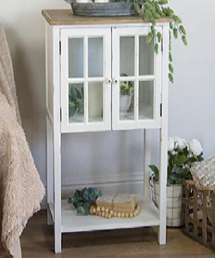

Hamptons 2 Glass Door Display Cabinet

$39.99

Availability: In stock

### Description

Create classic-factor to your room with Poliform French Provincial Classic Glass Display Cabinet. Poliform French Provincial Furniture’s are unique pieces for your home. This range includes Classic Dressers, Bookcases, TV Units, Desks, Writing Bureaus, Dining Settings, Occasional Chairs, Chesterfield Sofas and a Bedroom Collection that will look stunning in your newly built or renovated home. Poliform bringing the best of French Provincial Furniture to Australia at the best prices!